UNIVERSITY OF MICHIGAN – DEARBORN
College of Business

Presented by:
PADMINI POOJARI

FLINT WATER LINE REPLACEMENT
DS 633 – DATA MINING FOR BUSINESS ANALYTICS
Professor: David Kaufman

Contents
1.1 INTRODUCTION 3
1.2 DATA COLLECTION and PREPROCESSING 3
1.3 Exploratory Data Analysis (EDA) 4
Table 1: EDA Table 5
1.4 Predictive Models 7
1.5 Model Comparison 8
1.6 Conclusion 8
1.7 Scoring Instructions 8
Table 2: Scoring Instructions Table 9
1.8 Appendix 10
Table 3: Fit Details Table 10
Table 4: Column contributions Table 10
Table 5: Overall statistics Table 10
Table 6: Per-Tree summaries column contribution Table 11
Table 7: Boosted tree overall statistics Table 11
Table 8: Boosted tree column contribution Table 12
Table 9: Model NTanH(3) Table 13
Table 10: Logistic regression Table 13
Table 11: Settings Table 14

1.1 INTRODUCTION
The Flint River, which runs through the center of town, has been used for more than a century as an unofficial place to dispose of treated and untreated waste from the numerous local industries that have sprung up along its banks, including meatpacking plants, paper and lumber mills, carriage, and car factories, and more. the terrible choice made in 2013 to discontinue the city's five-decade tradition of piping treated water from Detroit to its citizens in favor of a less expensive option: pumping water from the Flint River in the interim until a new water pipeline from Lake Huron was constructed. Flint officials neglected to clean the highly corrosive river water, allowing lead to seep into thousands of homes through outdated pipes. Residents began to complain about the taste, smell, and appearance of the water coming from their taps shortly after the city started delivering Flint River water to its citizens in April 2014. Given that the water system in Flint has tens of thousands of lead pipes, locating and replacing them could be a costly and challenging task.
In this study, we intend to explore the variables linked with elevated lead levels in order to identify dwellings that are more likely to be contaminated with lead. We investigate whether lead contamination necessitates replacement of a home's water service line, which links it to Flint's water distribution system. Based on the sl_private_type and sl_public_type variables, we are examining the "Dangerous" target column. In order to forecast the 1 / 0 binary classification, we need to know if the water test result for the SL private type or SL public type is greater than or less than 15 ppb.

1.2 DATA COLLECTION and PREPROCESSING

We received the data to be analyzed from the Flint water Crisis team. The data was collected from various sources. The data set has information on 20697 entries regarding water samples. The target variable Dangerous is a nominal variable with 0 and 1 values.
Property data such as land value, owner type, building description data, parcel acres, use type, year the building was built, zoning information, property conditions, geographic data containing latitude and longitude, hydrant type and the results of testing the public and private service lines of a large sample of properties within the Flint city limits. There is also data that was collected from the basement of the Flint city hall that was carefully coded to the best of the intern that worked on the project for the properties sampled. We took this data and analyzed what we could find first in Tableau, a visualization software. Our next step was to analyze any missing data and to also understand the contents of the data.
Investigating the property IDs on that map below you can notice that properties that were found to have dangerous service lines either private or public, colored in yellow are fairly grouped together, either by street or by neighborhood. There are some that are mixed which we will have to investigate further.
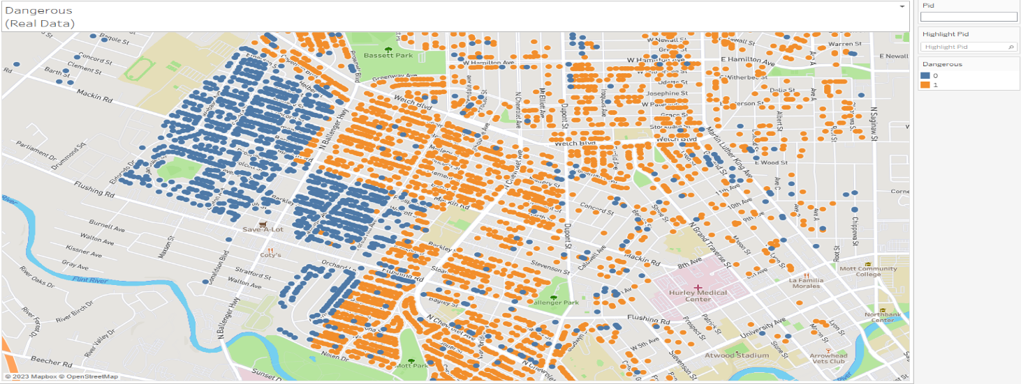

1.3 Exploratory Data Analysis (EDA)

The main column we identified early on was year built. When we looked at the mapping of the year built, what we noticed right away was a large amount in the area where there were many houses that had been found to have missing service lines. There also visually looked like there was a correlation between the year the house was built and having a dangerous service line. So, we knew this variable was important. Out of the 1250 instances, the data was not plausible, compared to the other values for Year built are values 0, 2, and 66. This is based on the fact that the city was founded as a village in 1819, according to Wikipedia, the oldest year-built house was 1800. In the data the newest year built was 2013. The average year built, excluding the non-plausible data, was 1943.
While trying to develop the criteria to populate the missing variable we thought of using averages by ward, Centract, Cenblock, and Zip code. All these variations did not look like they would be accurate. As we continued to work through the visualization, we noticed that if you looked at the unique property IDs and sorted them in order, they were directionally right next to each other. As we looked at the years the houses were built, they for the most part was directly correlated to each other geographically. Our next step was to create an excel file to sort and populate the year built. In some cases, we could automate the selection by selecting the row above or below based on how far away the property ID was away from the missing value. This did take some time to complete however it was worth the time to make sure we had the best assumption we could come up with. This was a hard decision on whether we spent the time, and maybe there could have been a better way but this seemed to be the best method to get something close to what the actual year built could be.
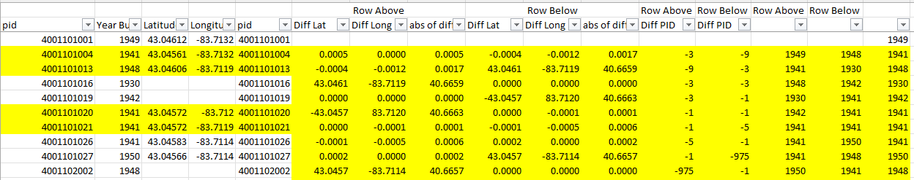

Table 1: EDA Table

Our EDA involved the following steps:
- We ignored three variables - pid, latitude, longitude, Rental, Use Type, Prop Class, USPS Vacancy, Future Land use - as they were not relevant to our analysis.
- We observed that Ward and Precinct were correlated, and hence we removed the Ward variable.
- We converted the Property Zip Code variable to a nominal variable.
- We noticed that CENTRACT and CENBLOCK provided the same information, and thus we dropped CENTRACT and CENBLOCK.
- We removed the variables sl_public_type and sl_private_type which gives the information on the Dangerous column.
- We combined Housing Condition 2012, Housing Condition 2014 and Commercial Condition 2013 and created a new column with Property Condition hence removed all other conditions.
- We observed that Zoning, DRAFT Zone and Precinct give the same information so we removed Draft Zone and Precinct.
- With the help of Tableau visualization, the property location ID with the latitude and longitude helped identify when sorted are co-located near each other and have similar years built. We created a new column New_Year Built.
- We Identified missing values in variables and the details are as follows:
- We observed there were 1250 missing values in Year Built, we imputed them with the mean year with the zone neighborhood year built.
- We observed there were 114 missing values in Residential Building style, we imputed them with one store building.
- We observed there were 2 missing values in Zoning, we imputed them based on the neighborhood ward and zoning values.
- We observed there were 59, 400,109 and 26760 missing values in USPS Vacancy, Housing condition 2012, Housing condition 2014 and Commercial Condition 2013 respectively, we ignored them as we are not used in our analysis.

The variables that come out on top are SL_Type, and New_YearBuilt. What we tend to find is that the records in the basement really add a lot to the contribution. At first, we were suspicious of the data as they were in rough shape and have possible errors.

Finally, we observed that 13 variables will contribute to fit the models for predicting the target column. The variables are: New_YearBuilt, SL_type, Zoning, Max_lead, Hydrant Type, Residential Building Value, Land Value, SL_private_inspection, Med_Lead, Parcel Acres, Residential Building Style, SL_Type 2 and Homestead.

1.4 Predictive Models
We have used following models to fit our data:
Logistic Regression:
We performed logistic regression analysis to examine the relationship between the predictor variables and the response variable. The primary goal was to identify and retain only the most significant variables, resulting in a simpler and more interpretable model. The approach was adopted to address the issue of having many predictor variables and determining the ones that are essential for the analysis. The validation data's R-squared value was 0.6648 with an accuracy of 91.52% and an error rate of 8.48%. The most frequent column contributors are SL_Type, New_YearBuilt followed by Zoning and Hydrant type.

Classification and Regression Trees (CART):
To verify the data obtained from logistic regression, we employed CART. Because CART is strong in handling missing data and can handle both continuous and categorical variables, it is useful. The decision tree that emerges from CART is simple to understand and offers perceptions into how the predictor factors and the desired outcome are related. 34 splits made up our CART model, and the validation data's R-squared value was 0.662 with an accuracy of 92.27% and an error rate of 7.73%. The two most frequent column contributors are SL_Type (28.12%) and New_YearBuilt (68.26%).

Boosted Tree:
An ensemble of decision trees is constructed using the boosted tree ensemble learning technique, with each new tree improving on the mistakes of the preceding one. With a generalized R-squared value of 0.6762, our boosted tree model outperformed the basic CART model by a wide margin. a 7.44% mistake rate and 92.56% accuracy. The column contributors that contribute most frequently are SL_Type (0.1063), New_YearBuilt (0.1567), Homestead (0.2639), and Hydrant type (0.1345).

Bootstrap Forest:
Bootstrap forests are another learning technique that builds a set of decision trees based on bootstrap samples from the training data. This method can handle multiple predictors and complex interactions between variables without adding them. Our bootstrap forest model produced a standardized R-squared value of 0.6842, which outperformed all previous models. The accuracy is 92.41% and the error rate is 7.59%. SL_Type (0.3672), New_YearBuilt (0.5077) are the main contributors to the column.

Neural Net:
We ran many neural nets to achieve the best AUC possible without overcomplicating and therefore overfitting the model. First, we ran models with a single hidden layer with three nodes and 3 TanH, 0 Linear, and 0 Gaussian activation functions respectively. Our model produced a standardized R-squared value of 0.7859. The accuracy is 92.08% and the error rate is 7.92%.

1.5 Model Comparison
The Receiver Operating Characteristic (ROC) curve's Area Under the Curve (AUC) is used to determine critical performance indicators for the models under consideration. The true positive rate versus the false positive rate is represented graphically by the ROC curve. It is employed to assess how well the models under evaluation perform.

The Bootstrap Forest model has the highest AUC based on the evaluation findings. This model is therefore being finalized as the suggested model. But before the model is finalized, additional factors are also considered.
The partitioning technique is among the factors being considered. While this is an excellent method for determining important variables, it may overfit the training set and underperform when applied to the test set. We tried using Bootstrap Forest and Boosted Tree models, which randomize the tree selection process, to solve the overfitting issue.

1.6 Conclusion
Using data mining techniques to identify lead in water pipes is one possible way to reduce the frequency of needless excavation visits and protect Flint residents' health. Our investigation has shown that the building's age and the precincts are important factors that consistently predict the possibility of lead contamination.
With an ROC of 0.9672, we have determined that the Bootstrap Forest model has the highest accuracy based on our investigation. By using this prediction model, it will be possible to identify the homes that are most likely to be contaminated with lead and to focus cleanup efforts more precisely.

1.7 Scoring Instructions
The best performing model, based on ROC AUC, was the Bootstrap Forest Model.
Therefore, we request that you score our performance using the hold-out test set data using the JMP Bootstrap Forest Model.
Step 1. Open the following JMP file: insert file name
Step 2. Copy the 6,166 records, representing the test set data, at the following location in the table
copy/paste the test set data over / on to the data set beginning at Row 20698, where the Test Data section begins (see image below)
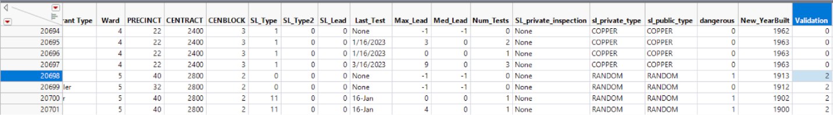

Table 2: Scoring Instructions Table

Step 3. After copying the test data set, re-execute the following Bootstrap Forest Macro, by selecting the following:
- select and execute the following script: RUN_ME__Boostrap Forest of dangerous - 13 pred
- re-execute / re-run the script again, using the following command:
- click the red triangle to the left of the window text ‘Bootstrap Forest for dangerous’ (see image below)
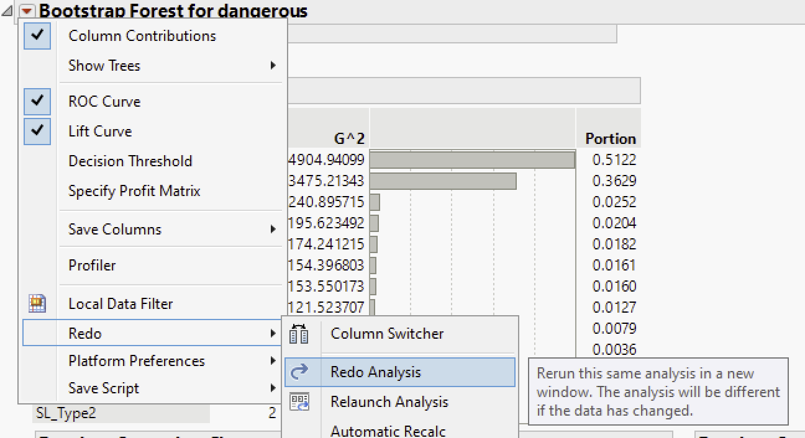
- Select ‘Redo / Redo Analysis’. The analysis will rerun.
Step 4. Analyze the results
- View the ROC curve for the Test Data Set (3rd graph, on right, labeled ‘Receiver Operating Characteristic on Test Data’
- On the top-right corner of this graph, read the Area value, when dangerous = 1
- This is the score of the Model on the hold-out data

1.8 Appendix
A1. JMP OUTPUTS
Decision Tree: error rate / column contributions / ROC Curves

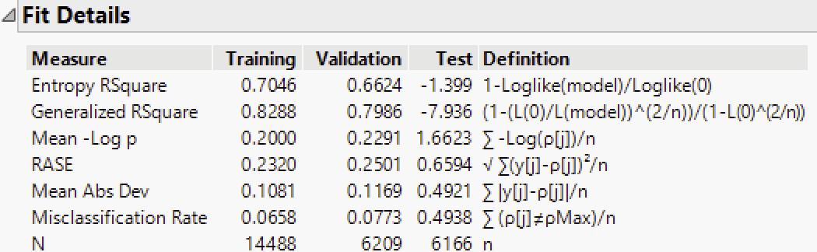

Table 3: Fit Details Table

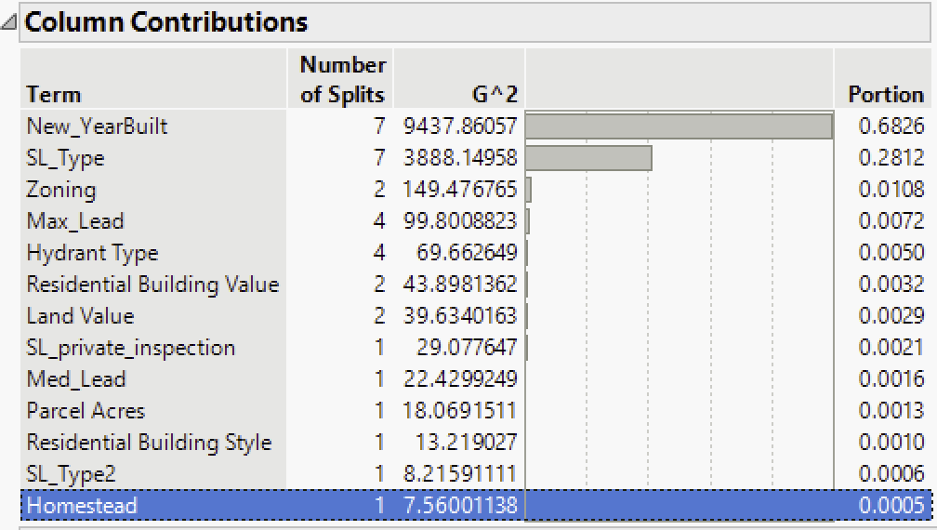

Table 4: Column contributions Table

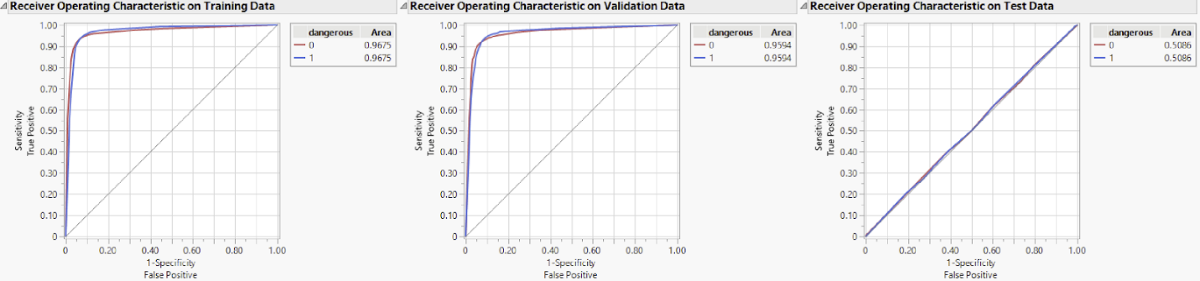

Bootstap Forest: error rate / column contributions / ROC Curves

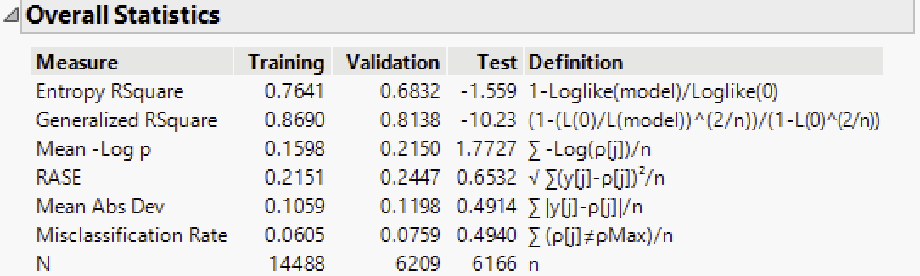

Table 5: Overall statistics Table

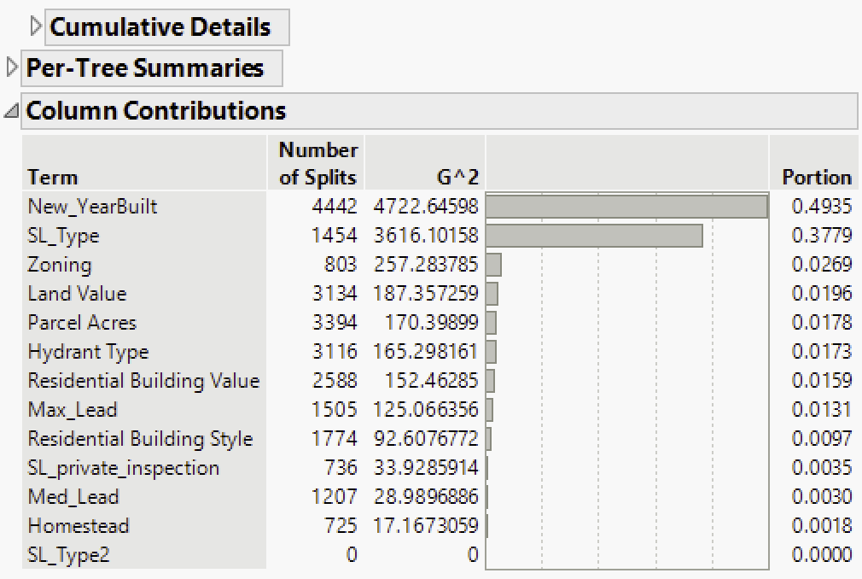

Table 6: Per-Tree summaries column contribution Table

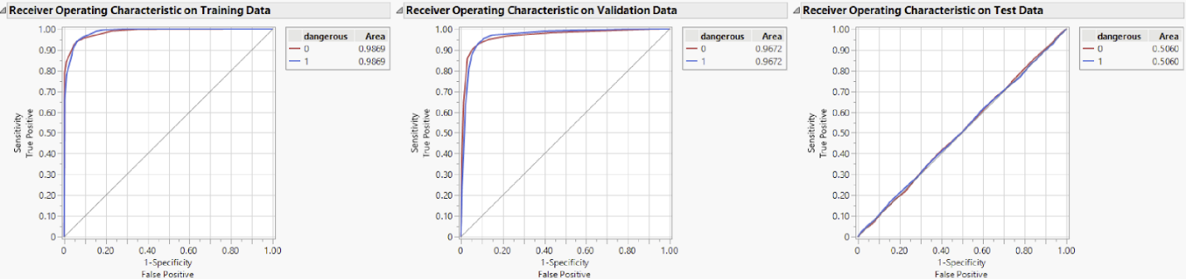

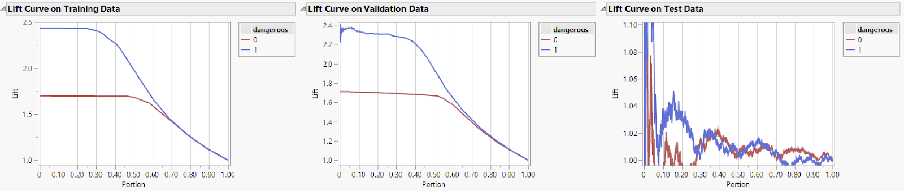

Boosted Tree: error rate / column contributions / ROC Curves

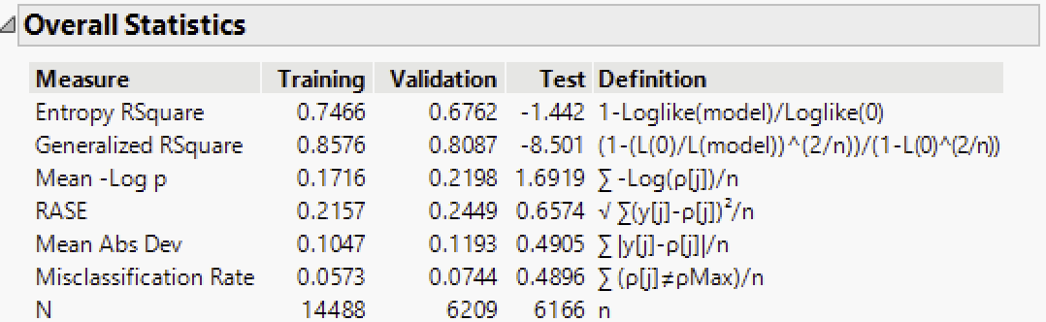

Table 7: Boosted tree overall statistics Table

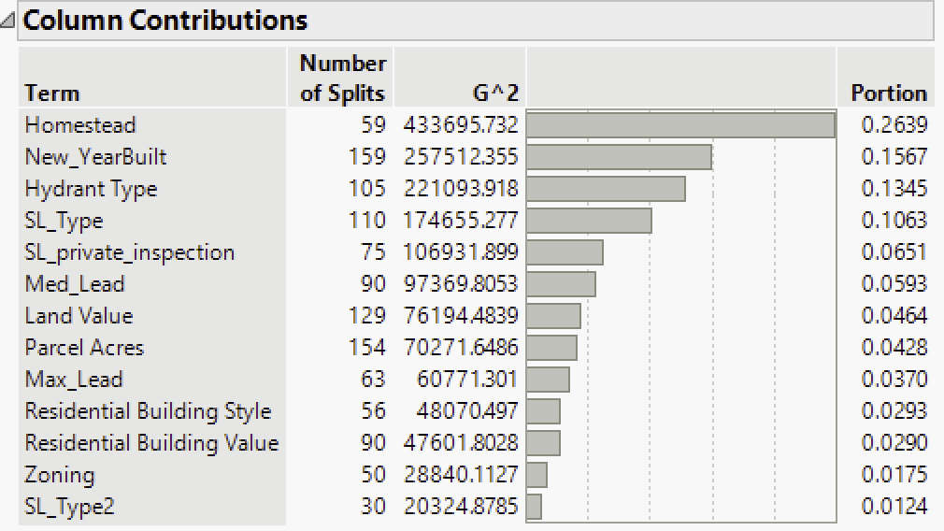

Table 8: Boosted tree column contribution Table

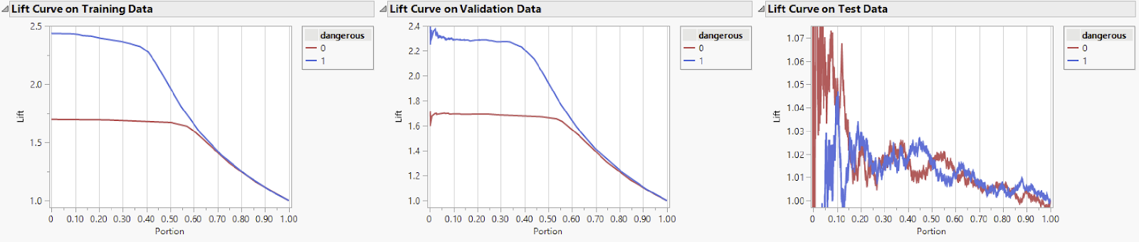
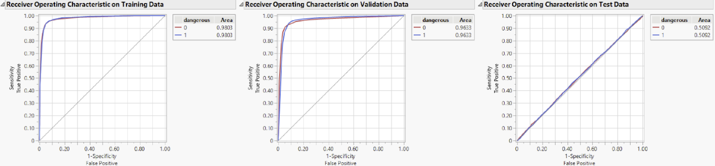

Neural Net: error rate / ROC Curve
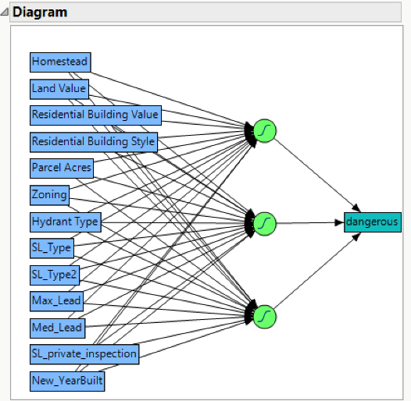

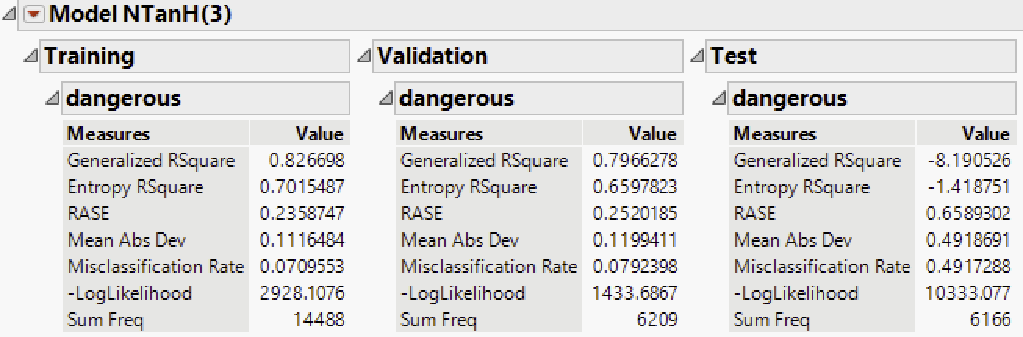

Table 9: Model NTanH(3) Table

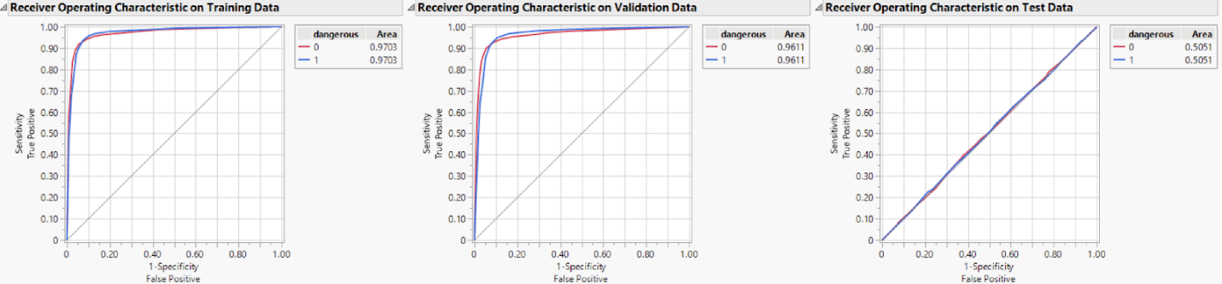

Logistic Regression: error rate / column contributions / ROC Curve

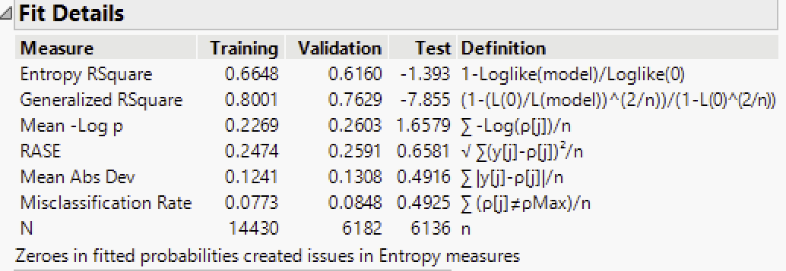

Table 10: Logistic regression Table

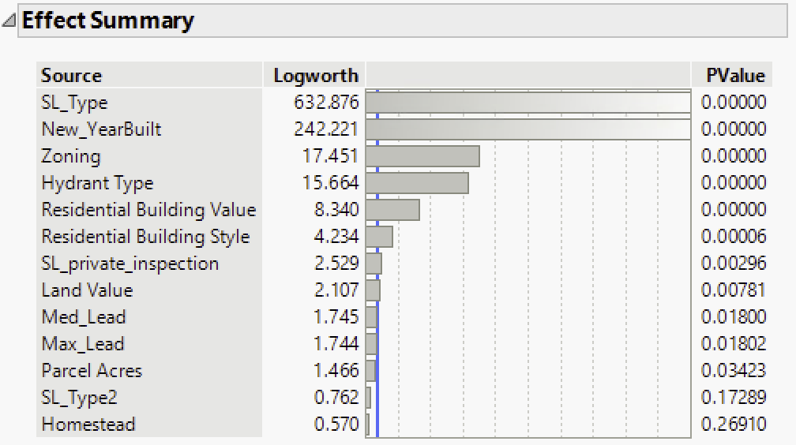

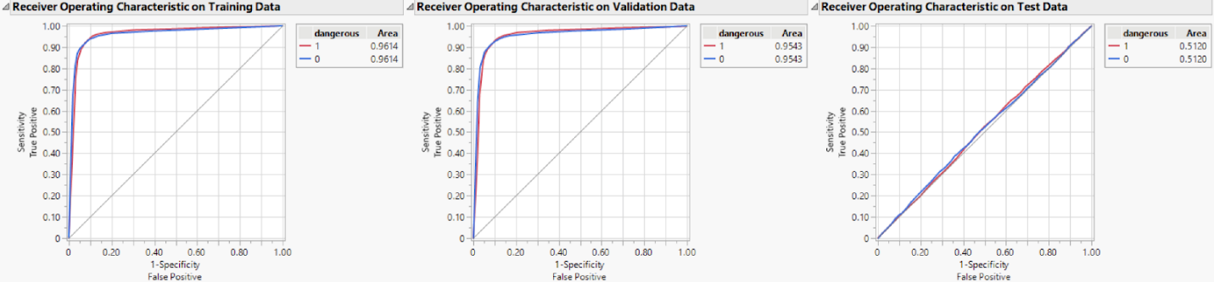

A2. DETAILS AND SETTINGS

Story elements for 2 highest predictors
- New Year Built

- SL Type
Table of Values
Number | Material
0 | Unkown/Other
1 | Copper
2 | Tubeloy
3 | Zinc
4** | Lead
5** | Copper/Lead
6 | Copper/Zinc
7 | Copper/Tubeloy
8** | Lead/Zinc
9** | Lead/Tubeloy
10 | Copper/?
11** | Galvanized/Other

Table 11: Settings Table

Of the 12 possible values for SL_Type, 5 (4,5,8,9,11) values will set SL_Lead to 1.

